Connect to and communicate with Stellarium

Connect to and communicate with Stellarium 0.17 or newer (http://stellarium.org/). If Stellarium is installed on the local machine enter for IP address 127.0.0.1. The default Port is 8090.
If Stellarium is on a remote machine set the IP and Port used there.
Before making a connection there is need to make some configurations in Stellarium:

In Configurations->Plugins make sure that "Remote Control" plug-in is configured as "Load at startup" 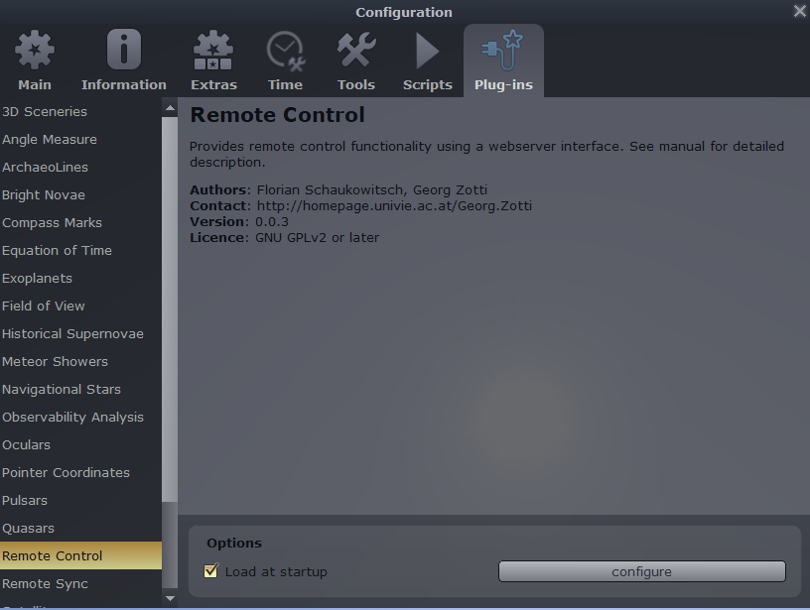
Restart Stellarium after enabling.
After that click on "configure" and enable the options "Server enabled" and "Enable automatically on startup"
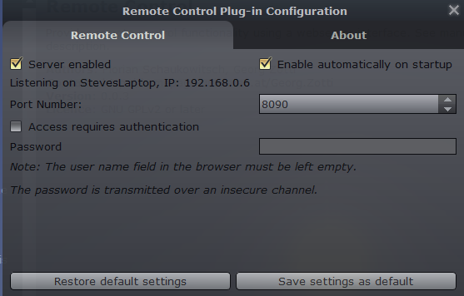
In Configurations->Plugins make sure that "Oculars" plug-in is configured as "Load at startup"
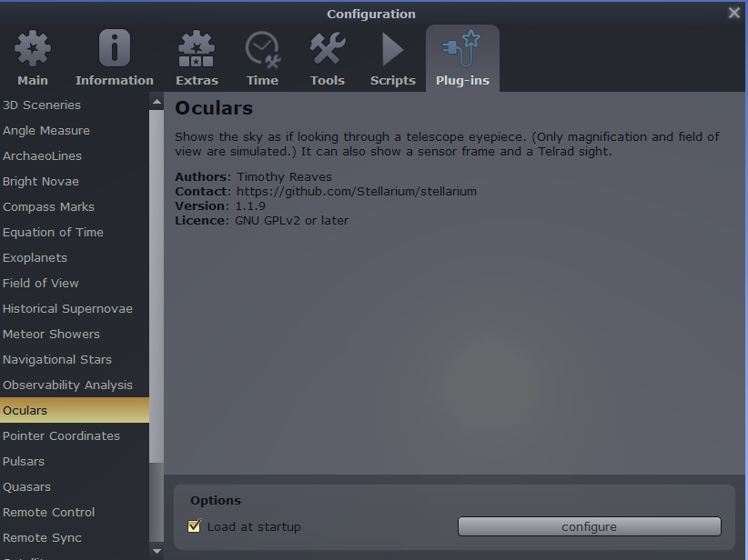
Restart Stellarium after enabling.

In "Oculars" configuration go to "Sensors" tab and define a new sensor or edit one of the existing. All the needed data can be found in the Object Calculator (for CCD/CMOS a connection is needed in order to determine the pixels count). Enter the number of the sensor in the APT settings. The first sensor is 0, the second 1 and so on (the index is zero based). So the one ringed in green is Ocular 0.

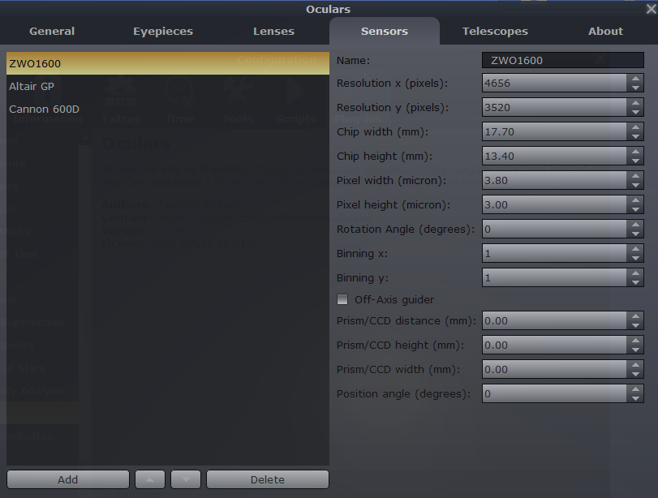
In "Oculars" configuration go to "Telescope" tab and define a new sensor or edit one of the existing. Enter the number of the telescope in the APT settings. The first scope is 0, the second 1 and so on (the index is zero based). So the one ringed in blue is 0
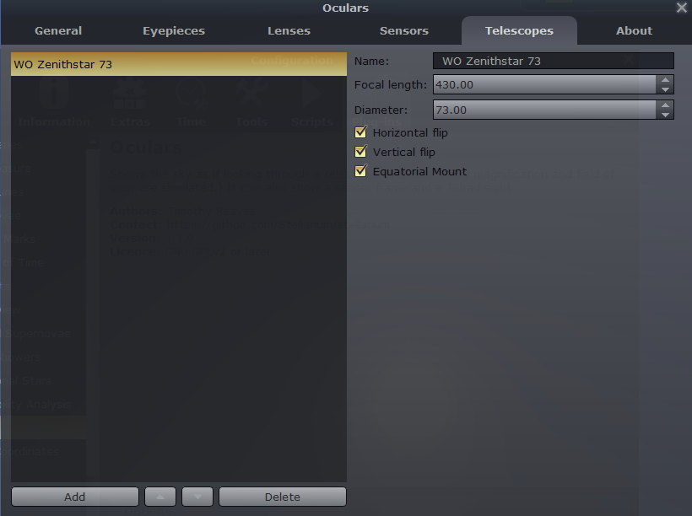

I am not sure the following is relevant to communicating with Stellarium from APT but the settings are as follows:-
In Configurations->Plugins make sure that "Remote Sync" plug-in is configured as "Load at startup"
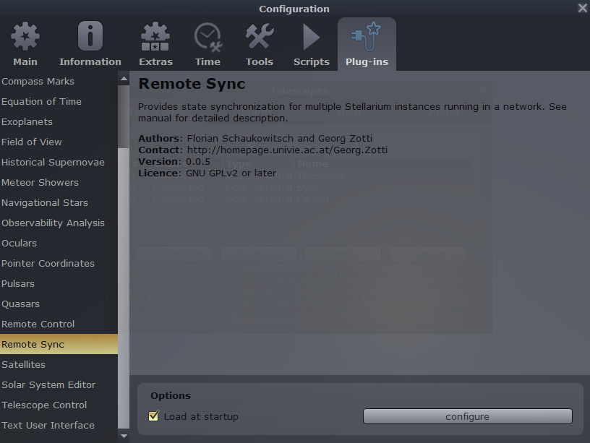
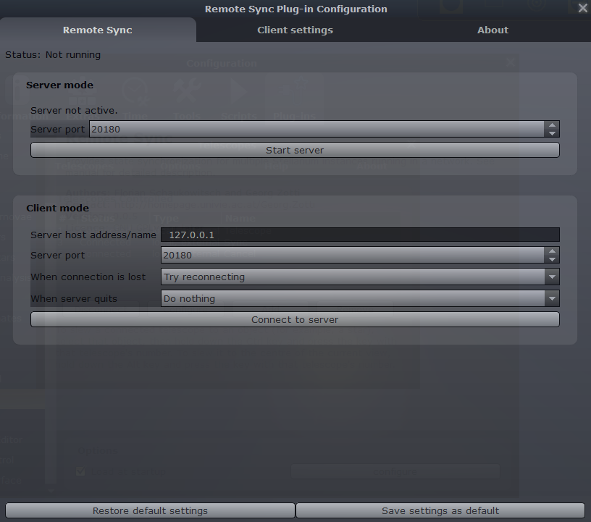
Settings as follows:

In Configurations->Plugins make sure that "Telescope Control" plug-in is configured as "Load at startup"
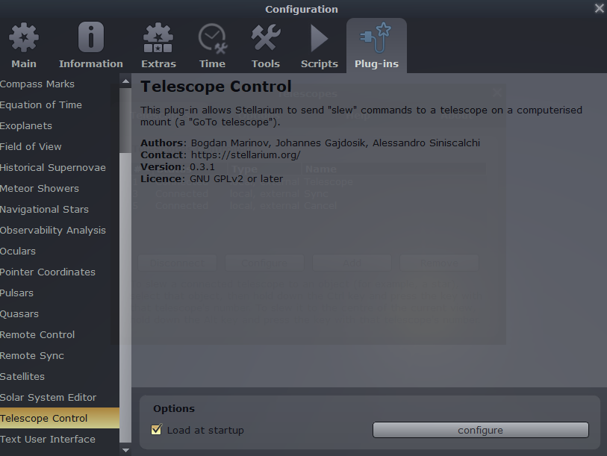
In Configuration:
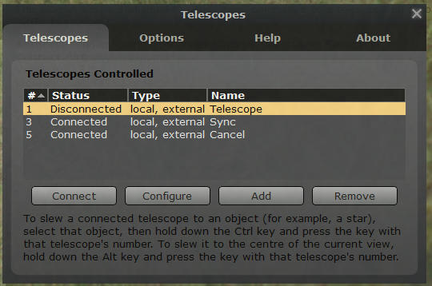
Click on “Configuration”:
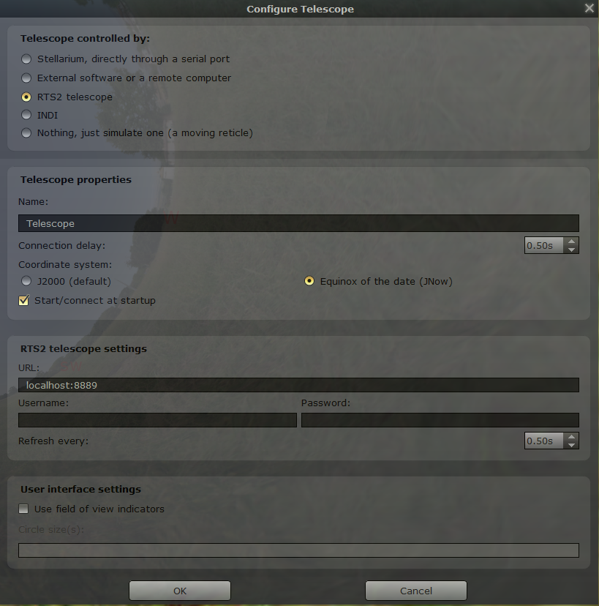
In Options:
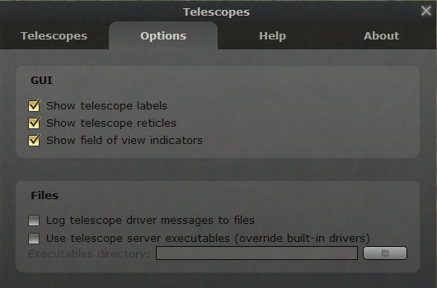

Then in APT Settings – Planetarium :
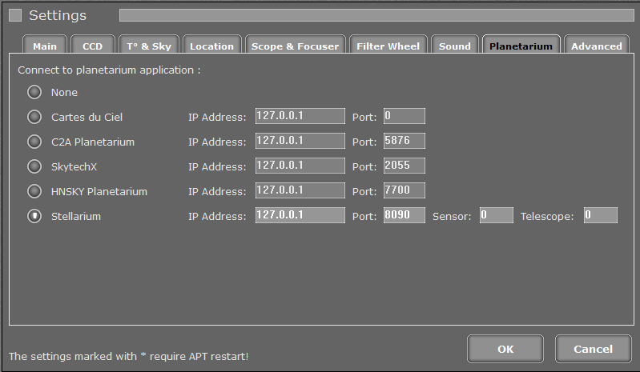

NOTE: The ringed settings above tie up with settings in Stellarium described earlier.

