Barn Door Tracker Project

- Items obtained.
Ball joint.
M6 threaded rods.
M6 nuts (hexagonal and wing).
M6 washers and larger washers.
M6 T thread nuts.
3/8” hot shoe connection for ball head connection.
2xDVD’s.
Heavyweight Alt-Az mount.
Polar scope.
Polar scope tube holder.
Android App to aid polar alignment.
Printed off curve for bent rod.
Gloss black and red paint.
Wood for the build. Dimensions. Main boards 12mm thick 75mm wide. Rotating circle 6mm thick plywood. 110mm diameter.
Battery clock mechanism retaining the second hand.
13.2.2017. Ordered the following electronic parts for future motorised builds-
X3 1.5-6.5 volt dc motor.
X3 regulators, one reversible.
Battery pack connector 4x1.5 volts (x2) and 9 volt (x10) connectors.
All electronic parts gathered during March.
- Decide on build design-boxed base or flat base. Flat base used.
Curved rod making method. First rod was manually bent and also squeezed between wooden pattern. Future rods will be squeezed using wooden pattern.
Notes
12.3.2017. The first BDT was built in February 2017 and at the time of writing is still undergoing testing as clear night skies allow. A detailed account of the pro’s and con’s of the build are being drawn up to feed into future builds.
Notes from making the Barn door Tracker

- Use better quality 12mm ply for the base and top boards.
- Alternatively try mdf.
- No need to shape the boards, rectangular shape is fine.
- Use of ¼” to 3/8” adapter works well for connecting base board to tripod.
- Using 6mm T-nut works well to secure rotating disc to threaded rod.
- Bending rod using two pieces of shaped wood and clamp works well.
- The upper board needs to have a slot rather than a hole made into it for the threaded rod to pass through.
- Try using a piano hinge in place of a larger 75mm brass hinge.
- The connection point for the ball head could be relocated closer to the hinged end and to one side to better miss the length of threaded rod, allowing use of a longer >150mm useable length of rod for tracking.
- Use of adhesive Velcro for the clock mechanism works on the tripod mount works well allowing the battery to be replaced when needed.
- Add pins at ¼ points of disc to help rotate smoothly.
- Add a CD disc to the upper surface of the rotating disc to further reduce friction and juddering transmitted to the camera.
Photograph of the Mark I build before addition of the CD to the rotating disc-

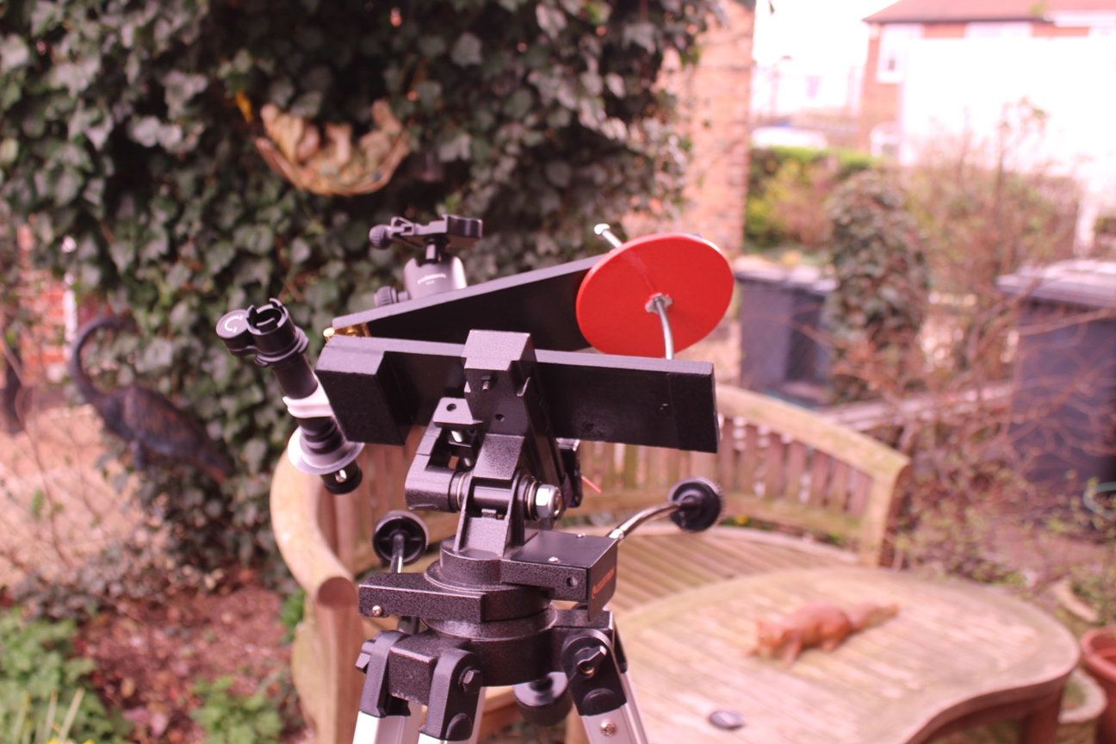

Further enhancements made to maximise tracking duration have been-

- Practice polar alignment to be as accurate as possible. The polar scope gives an inverted, mirror image. Focus of the polar scope.
- Purchased a right angled accessory for the polar scope making polar alignment more comfortable in the field.
- Gluing a CD disc to the upper surface of the rotating disc to further reduce friction and uneven movement being transferred to the camera.
- Add marks at the ¼ positions of the rotating disc and a reference point at the upper corner of the upper arm to help a smooth, unhindered movement of the rotating disc.
- For a 35mm FL lens rotating the disc ¼ turn every 15 seconds has permitted exposures of 150 seconds..
The set up of tripod and tracker.

